**A**

**Project Report**

**On**

**“E-Commerce Website”**

**In partial fulfilment of requirement for the degree of**

**Bachelor of Technology**

**In**

**Computer Science & Engineering**

**By**

# Students Registration No

Asmit Sahoo 2001301030

**Under the Guidance of**

**Pradhan Bage,** **Asst. Prof CSE**

**DEPARTMENT**

**OF**

# COMPUTER SCIENCE & ENGINEERING

**VIGNAN INSTITUTE OF TECHNOLOGY AND MANAGEMENT**



# CERTIFICATE

This is to certify that we have examined the project entitled **“E-Commerce Website”** has been submitted by **Asmit Sahoo,** bearing Registration Number **2001301030,** under my guidance in partial fulfilment of the degree of Bachelor of Technology in **Computer Science & Engineering** of Biju Patnaik University of Technology, Rourkela during the academic year 2023-2024.

This is for the partial fulfilment of the requirement of the Bachelor of Technology in **Computer Science & Engineering**, **Vignan Institute of Technology and Management, Berhampur** under Biju Patnaik University of Technology.

## **Signature of Guide Signature of HOD**

## **Prof. Pradhan Bage Prof. B. SRINIVAS RAO**

## **Asst,Prof CSE (Prof. & HOD, CSE)**

# DECLARATION

We do hereby that declare we have undergone a project on “E-Commerce Website” at Vignan Institute of Technology and Management, under the guidance Prof. **Pradhan Bage**, department of Computer Science & Engineering, Vignan Institute of Technology and Management, Berhampur.

We submit this report in partial fulfilment of the requirement for the Bachelor in Technology in Computer Science & Engineering from Vignan Institute of Technology and Management, Berhampur. The report is exclusively & comprehensively prepared & conceptualized by us. All the information & data given here in this project are collected during our study from sources & it has not been published anywhere before.

**Registration number Students Name**

**2001301030 Asmit Sahoo**

**ACKNOWLEDGEMENT**

This work was completed due to the grace of almighty god we are highly indebted to god that he has given the strength and encouragement to complete this work and hope his blessings will continue to be showered on us so that we can achieve the goal of our lives.

We avail this opportunity to place my profound gratitude to my guide **Prof. Pradhan Bage** Department of **Computer Science & Engineering** for his constant supervision, inspiration and encouragement, right from the beginning of the seminar report entitled **“E-Commerce Website”.**

We also indebted to **Prof. B. Srinivas Rao**, HOD of Computer Science Engineering for his help and advice in completion of this seminar report.

Finally, we would like to extend my sincere thanks to all my friends and all persons who have rendered their valuable help directly or indirectly in the completion of this seminar report.

**Registration number Students Name**

**2001301030 Asmit Sahoo**

**ABSTRACT**

This project aims to create an E-commerce website using HTML, CSS, and JavaScript. The website will provide users with a platform to browse and purchase products online. The main objectives of this project include designing an intuitive user interface, implementing secure payment gateways, and incorporating dynamic functionalities.

The project will begin by structuring the website's layout using HTML, ensuring a responsive design that adapts to different screen sizes. CSS will be utilized to enhance the website's aesthetics and create visually appealing user interfaces. JavaScript will be employed to add interactivity, such as dynamic product filtering, shopping cart functionality, and real-time updates.

The website will feature various sections, including a homepage showcasing featured products and promotional offers. Users will be able to navigate through different product categories, view detailed product pages with descriptions, images, and customer reviews. Additionally, a search functionality will be implemented to facilitate easy product discovery.

To ensure secure transactions, the project will integrate popular payment gateways like PayPal or Stripe. Users will have the option to securely enter their payment details and complete purchases. Furthermore, the project will incorporate user authentication and authorization mechanisms to protect sensitive user information.

Overall, this project aims to deliver a fully functional E-commerce website that provides an enjoyable shopping experience for users. By leveraging HTML, CSS, and JavaScript, it will enable seamless navigation, attractive visuals, dynamic features, and secure transactions.

**CONTENTS**

**Chapters Names Page No**

1. INTRODUCTION 01

* 1. Objective 01
  2. About the project 02
  3. Scope of the project

2. REQUIREMENT 03

2.1 Hardware Requirements 03

2.2 Software Requirement 04

3. REQUIREMENT ANALYSIS 05

3.1. System Analysis 05

3.2 Proposed System 05

3.3 System Feasibility 06

4. WEBSITE DESGN 07

4.1 Overall Description 07

4.2 Functional Requirements 07

4.3 Description 07

4.4 Registration Of New User 08

5. DIAGRAM 09

6. SOURCE CODE 12

7.SNAPSHOTS 38

8.SCOPE OF E-COMMERCE WEBSITE41

9.CONCLUSIONS 43

10.REFERENCES45

**LIST OF FIGURES**

**Serial No. Figure No. Figure Caption/Description Page No.**

1 Figure 5.1 UML diagram 09

2 Figure 5.2 Use Case Diagram 10

3 Figure 5.3 User Diagram 11

4 Figure 7.1 Home page 38

5 Figure 7.2 Product list 38

6 Figure 7.3 Single Product Page 34

7 Figure 7.4 Navigation Bar 34

8 Figure 7.5 Contact page 40

9 Figure 7.6 Cart Page 40

**Serial No. Table No. Table Caption/Description Page No.**

1 Table 2.1 Hardware Requirement 03

2 Table 2.2 Software Requirement 04

**CHAPTER-1**

**INTRODUCTION**

* 1. **Objective**:

The objectives of an e-commerce website can vary depending on the business. However, some common objectives are:

1. **Reaching more customers**: E-commerce can help businesses reach a wider audience by eliminating geographical barriers and providing 24/7 accessibility to their products or services.
2. **Optimizing operational costs**: Emit-commerce can help businesses reduce operational costs by automating certain processes and reducing the margin of errors that come from responding to each customer directly
3. **Delivering a better customer experience**: E-commerce allows customers to quickly and easily find the best solution for their needs. This can lead to higher customer satisfaction and loyality.
4. **Improving available data for marketing and product development**: E-commerce provides businesses with valuable data on customer behavior, preferences, and purchase history. This data can be used to improve marketing strategies and product development.
   1. **About the project**:

An online shopping system that permits a customer to submit online orders for items and/or services from a store that serves both walk-in customers and online customers. The online shopping system presents an online display of an order cut off time and an associated delivery window for items selected by the customer. The system accepts the customer's submission of a purchase order for the item in response to a time of submission being before the order cut off time. The online shopping system does not settle with a credit supplier of the customer until the item selected by the customer is picked from inventory but before it is delivered. Therefore, the customer can go online and make changes to the order. In addition, available service windows are presented to the customer as a function of customer selected order and service types and further, the order picking is assigned in accordance with a picker's preference. When ordering goods, many shopping systems provide a virtual shopping cart for holding items selected for purchase. Successive items selected for purchase are placed into the virtual shopping cart until a customer completes their shopping trip. Virtual shopping carts may be examined at any time, and their contents can be edited or deleted at the option of the customer. Once the customer decides to submit a purchase order, the customer may print the contents of the virtual shopping basket in order to obtain a hard copy record of the transaction

* 1. **Scope of the project**:

• The current system can be extended to allow the users to create accounts and save products in to wish list.

• The users could subscribe for price alerts which would enable them to receive messages when price for products fall below a particular level.

• The current system is confined only to the shopping cart process. It can be extended to have a easy to use check out process.

• Users can have multiple shipping and billing information saved. During checkout they can use the drag and drop feature to select shipping and billing information.

**CHAPTER - 02**

**HARDWARE AND SOFTWARE REQUIREMENT**

**2.1** **Hardware Requirements**:

|  |  |  |
| --- | --- | --- |
| **NO** | **Name** | **Requirement** |
| 1 | Processor | Core i3/i5/ i7 |
| 2 | RAM | 4GB or above |
| 3 | Hard Disk | 512GB or above |

**Table 2.1** **Hardware Requirement**

**2.2** **Software Requirement:**

|  |  |  |
| --- | --- | --- |
| **No** | **Name** | **Requirement** |
| 1 | Operating System | Window 10 / 11 |
| 2 | User Interface | HTML, CSS |
| 3 | Client-side Scripting | JavaScript(js) |
| 4 | Programming Language | Java script |
| 5 | IDE/Workbench | VS Code 1.84.2 |
| 6 | Web Application | XAMPP 8.2.4 |
| 7 | Database | MySQL |

**Table 2.2** **Software Requirement**

**CHAPTER - 03**

**REQUIREMENT ANALYSIS AND SPECIFICATION**

**3.1. System Analysis**

After carefully analyzing the requirements and functionality of the web application, I had two important diagrams by the end of the analysis phase. They are the ER diagram and data flow diagram which were the basis for finding out entities and relationships between them, the flow of information.

**3.1.1. Limitations of Existing System**

• The existing system is not user friendly.

• Loss of resources.

• Unavailability Of Payment Gateway

• Security issues and interpersonal conflicts

**3.2 Proposed System:**

In this proposed system we can implement a system which can manage project congnate all work consummated by project co-ordinaters. Co-ordinatre update project cognate information, view work done by the developers at which time and view progress chart of work. Developers retrieve the given work information updates and consummates this work at given time and submits into the project management system. The proposed system have a lot of advantages because we over the limitation of the existing system.

**3.1.2 Advantages of Proposed System**

• Good Discounts and Offer Prices

• Varities in products

• A Convinient and flexible way of shopping

• Best way to send gifts

• Time saving

• Easy to use

**3.2 Software Requirement Specification: Add SRS as submitted earley**

As the goal of the application is ease of use and to provide an interactive interface, extensive research has been done to gain an insight into the needs and behaviours of various users. The working of the application is made convenient and easy to use for the end user. Users can be classified into two types based on their knowledge of the products that suit their needs. They can be classified as users who know about the product that would satisfy their needs and users who have to figure out the product that would satisfy their needs. Users who know about the product should be able to find the product easily with the click of a button. Such users can search for the product by using the product name as the search term. Users who have to figure out the product that would satisfy their needs could use a search term to find a list of products and then should be able to filter the results based on various parameters like product type, manufacturer, price range, platform supported etc. The users should be able to view the complete specification of the product and various images at different Zoom levels. The user should be able to read the customer reviews for the product and the ratings provided. They should be able to write their own reviews.

They should be able to print out the specifications for a product or email the product page to a friends etc. To increase the ease of use the user should be able to add a product to the shopping cart by dragging a product and dropping it in the shopping cart. A user should able to edit the contents of a shopping cart. They should be able to update the quantities of the products added to the cart and remove the products from the cart. The user should be able to remove the product from the shopping cart by dragging the product and dropping it outside the cart. The application can be made interactive by pop up messages when a product has been dropped in to the shopping cart or out of the shopping cart. The user can be notified for if the cursor enters a drop area and the object that could be dropped. Also users are impatient making it important to load pages soon. Other than this, I did a lot of research on various other methods of building this application which and was able to incorporate a few stronger features into the application.

**3.3 System Feasibility**

The system feasibility can be divided into the following sections:

**3.3.1 Economic Feasibility**

The project is economically feasible as the only cost involved is having a computer with the minimum requirements mentioned earlier. For the users to access the application, the only cost involved will be in getting access to the Internet

**3.3.2 Technical Feasibility**

To deploy the application, the only technical aspects needed are mentioned below: Operating Environment Win 2000/XP Platform .Net Framework & IIS Database SQL Server 2005 For Users: Internet Browser Internet Connection

**3.3.3 Behavioural Feasibility**

The application requires no special technical guidance and all the views available in the application are self explanatory. The users are well guided with warning and failure messages for all the actions taken.

**CHAPTER - 04**

**WEBSITE DESIGN**

**4.1 Overall Description:**

The E-Commerce Website enables vendors to set up online shops, customers to browse through the shops, and a system administrator to approve and reject requests for new shops and maintain lists of shop categories. Also the developer is designing an online shopping site to manage the items in the shop and also help customers to purchase them online without visiting the shop physically.The online shopping system will use the internet as the sole method for selling goods to its consumers.

**4.1.1 Product Perspective:**

This product aimed toward a person who don’t want to visit the shop as he might don’t get time for that or might not interested in visiting there and dealing with lot of formalities.

1. User Characteristics:

User should be familiar with the terms like login,register, order system etc.

Principle Actors: 2 Principle Actors are Customer and Administrator.

General Constraints: A full internet connection is required for E-Commerce Website.

Assumptions and Dependencies: Working of E-Commerce Website needs Internet Connection

**4.2 Functional Requirements**:

This section provides requirement overview of the system. Various functional modules that can be implemented by the system will be –

**4.3 Description:**

1. Registration If customer wants to buy the product then he/she must be registered, unregistered user can’t go to the shopping cart.

2. Login Customer logins to the system by entering valid user id and password for the shopping.

3. Changes to Cart Changes to cart means the customer after login or registration can make order or cancel order of the product from the shopping cart.

4. Payment In this system we are dealing the mode of payment by Cash We will extend this to credit card, debit card etc in the future.

5. Logout After ordering or surfing for the product customer has to logout.

**4.4 Registration Of New Users:**

A new user will have to register in the system by providing essential details in order to view the products in the system. The admin must accept a new user by unblocking him. Functional requirement – System must be able to verify and validate information.

- The system must encrypt the password of the customer to provide security.

**-** Purchasing an item.

Description of Shopping Cart:

The user can add the desired product into his cart by clicking add to cart option on the product. He can view his cart by clicking on the cart button. All products added by cart can be viewed in the cart. User can remove an item from the cart by clicking remove. After confirming the items in the cart the user can submit the cart by providing a delivery address. On successful submitting the cart will become empty.

**CHAPTER - 05**

**DIAGRAM**

**5.1 UML Diagram:**

The Unified Modeling Language allows the software engineer to express an analysis model using the modeling notation that is governed by a set of syntactic semantic and pragmatic rules. A UML system is represented using five different views that describe the system from distinctly different perspective. Each view is defined by a set of diagram, which is as follows.

**5.1: UML Diagram**

# 5.2 Use Case Diagram for Admin:

# 

# 

**5.2: Use Case Diagram**

# 5.3 USER Diagram:

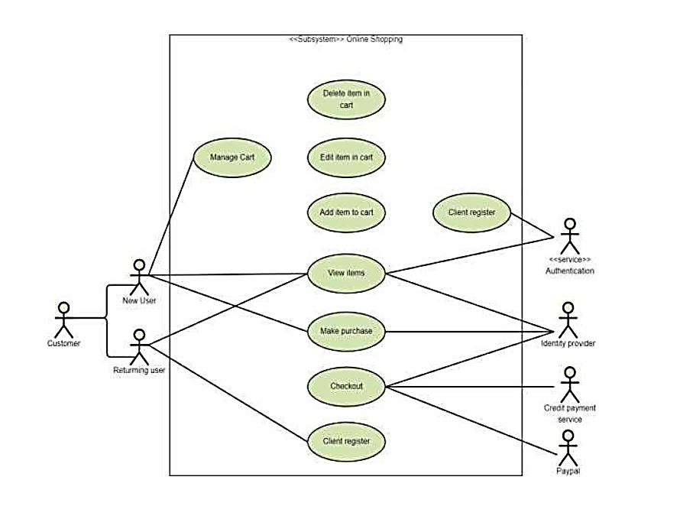

**5.3: User Diagram**

**CHAPTER – 06**

**SOURCE CODE**

# Index.html

<!DOCTYPE html>

<html lang="en">

    <head>

        <meta charset="UTF-8">

        <meta http-equiv="X-UA-Compatible" content="IE=edge">

        <meta name="viewport" content="width=device-width, initial-scale=1.0">

        <title>Ecommerce</title>

        <link rel="stylesheet" href="https://pro.fontawesome.com/releases/v5.10.0/css/all.css"/>

        <link rel="stylesheet" href="style.css">

    </head>

    <body>

        <section id="header">

            <a href="#"><img src="img/logo.png" class="logo" alt=""></a>

            <div>

                <ul id="navbar">

                    <li><a class="active" href="index.html">Home</a></li>

                    <li><a href="shop.html">Shop</a></li>

                    <!--<li><a href="blog.html">Blog</a></li>-->

                    <li><a href="about.html">About</a></li>

                    <li><a href="contact.html">Contact</a></li>

                    <li id="lg-bag"><a href="shop.html"><i class="far fa-shopping-bag"></i></a></li>

                    <a href="#" id="close"><i class="far fa-times"></i></a>

                </ul>

            </div>

            <div id="mobile">

                <a href="shop.html"><i class="fas fa-shopping-cart"></i>

                    <i id="bar" class="fas fa-outdent"></i>

            </div>

        </section>

        <section id="hero">

            <h4>Trade-in-offer</h4>

            <h2>Super value deals</h2>

            <h1>On all products</h1>

            <p>Save more with coupons & up to 70% off!</p>

            <button>Shop now</button>

        </section>

        <section id="feature" class="section-p1">

            <div class="fe-box">

                <img src="img/features/f1.png" alt="">

                <h6>Free shipping</h6>

            </div>

            <div class="fe-box">

                <img src="img/features/f2.png" alt="">

                <h6>online Order</h6>

            </div> <div class="fe-box">

                <img src="img/features/f3.png" alt="">

                <h6>Save Money</h6>

            </div> <div class="fe-box">

                <img src="img/features/f4.png" alt="">

                <h6>Promotions</h6>

            </div> <div class="fe-box">

                <img src="img/features/f5.png" alt="">

                <h6>Happy Sell </h6>

            </div> <div class="fe-box">

                <img src="img/features/f6.png" alt="">

                <h6>24/7 Support</h6>

            </div>

        </section>

        <section id="product1" class="section-p1">

            <h2>Featured Products</h2>

            <p>Summer Collection New Morden Design</p>

            <div class="pro-container">

                <div class="pro">

                    <img src="img/products/f1.jpg" alt="">

                    <div class="des">

                        <span>Rodster</span>

                        <h5>Fit Graphic Print Shirt</h5>

                        <div class="star">

                            <i class="fas fa-star"></i>

                            <i class="fas fa-star"></i>

                            <i class="fas fa-star"></i>

                            <i class="fas fa-star"></i>

                            <i class="fas fa-star"></i>

                        </div>

                        <h4>₹749</h4>

                    </div>

                    <a href="#"><i class="fal fa-shopping-cart cart"></i></a>

                </div>

                <div class="pro">

                    <img src="img/products/f2.jpg" alt="">

                    <div class="des">

                        <span>Rodster</span>

                        <h5>Fit Graphic Print Shirt</h5>

                        <div class="star">

                            <i class="fas fa-star"></i>

                            <i class="fas fa-star"></i>

                            <i class="fas fa-star"></i>

                            <i class="fas fa-star"></i>

                            <i class="fas fa-star"></i>

                        </div>

                        <h4>₹749</h4>

                    </div>

                    <a href="#"><i class="fal fa-shopping-cart cart"></i></a>

                </div>

                <div class="pro">

                    <img src="img/products/f3.jpg" alt="">

                    <div class="des">

                        <span>Rodster</span>

                        <h5>Fit Graphic Print Shirt</h5>

                        <div class="star">

                            <i class="fas fa-star"></i>

                            <i class="fas fa-star"></i>

                            <i class="fas fa-star"></i>

                            <i class="fas fa-star"></i>

                            <i class="fas fa-star"></i>

                        </div>

                        <h4>₹749</h4>

                    </div>

                    <a href="#"><i class="fal fa-shopping-cart cart"></i></a>

                </div>

                <div class="pro">

                    <img src="img/products/f4.jpg" alt="">

                    <div class="des">

                        <span>Rodster</span>

                        <h5>Fit Graphic Print Shirt</h5>

                        <div class="star">

                            <i class="fas fa-star"></i>

                            <i class="fas fa-star"></i>

                            <i class="fas fa-star"></i>

                            <i class="fas fa-star"></i>

                            <i class="fas fa-star"></i>

                        </div>

                        <h4>₹749</h4>

                    </div>

                    <a href="#"><i class="fal fa-shopping-cart cart"></i></a>

                </div>

                <div class="pro">

                    <img src="img/products/f5.jpg" alt="">

                    <div class="des">

                        <span>Altair</span>

                        <h5>Casual Shirt</h5>

                        <div class="star">

                            <i class="fas fa-star"></i>

                            <i class="fas fa-star"></i>

                            <i class="fas fa-star"></i>

                            <i class="fas fa-star"></i>

                            <i class="fas fa-star"></i>

                        </div>

                        <h4>₹699</h4>

                    </div>

                    <a href="#"><i class="fal fa-shopping-cart cart"></i></a>

                </div>

                <div class="pro">

                    <img src="img/products/f6.jpg" alt="">

                    <div class="des">

                        <span>Levi's</span>

                        <h5>Casual Shirt</h5>

                        <div class="star">

                            <i class="fas fa-star"></i>

                            <i class="fas fa-star"></i>

                            <i class="fas fa-star"></i>

                            <i class="fas fa-star"></i>

                            <i class="fas fa-star"></i>

                        </div>

                        <h4>₹699</h4>

                    </div>

                    <a href="#"><i class="fal fa-shopping-cart cart"></i></a>

                </div>

                <div class="pro">

                    <img src="img/products/f7.jpg" alt="">

                    <div class="des">

                        <span>Lohiya</span>

                        <h5>Rayon Trousers</h5>

                        <div class="star">

                            <i class="fas fa-star"></i>

                            <i class="fas fa-star"></i>

                            <i class="fas fa-star"></i>

                            <i class="fas fa-star"></i>

                            <i class="fas fa-star"></i>

                        </div>

                        <h4>₹799</h4>

                    </div>

                    <a href="#"><i class="fal fa-shopping-cart cart"></i></a>

                </div>

                <div class="pro">

                    <img src="img/products/f8.jpg" alt="">

                    <div class="des">

                        <span>Metro fashion</span>

                        <h5>Flute sleeves printed women top</h5>

                        <div class="star">

                            <i class="fas fa-star"></i>

                            <i class="fas fa-star"></i>

                            <i class="fas fa-star"></i>

                            <i class="fas fa-star"></i>

                            <i class="fas fa-star"></i>

                        </div>

                        <h4>₹499</h4>

                    </div>

                    <a href="#"><i class="fal fa-shopping-cart cart"></i></a>

                </div>

            </div>

        </section>

        <section id="banner" class="section-m1">

            <h4>Repair Services</h4>

            <h2>Up to <span>70% OFF</span> All t-shirts & Accessories</h2>

            <button class="normal">Explore More</button>

        </section>

        <section id="product1" class="section-p1">

            <h2> New Arrivals</h2>

            <p>New Formal Collection</p>

            <div class="pro-container">

                <div class="pro">

                    <img src="img/products/n1.jpg" alt="">

                    <div class="des">

                        <span>Arrow</span>

                        <h5>Regular fit Formal Shirt</h5>

                        <div class="star">

                            <i class="fas fa-star"></i>

                            <i class="fas fa-star"></i>

                            <i class="fas fa-star"></i>

                            <i class="fas fa-star"></i>

                            <i class="fas fa-star"></i>

                        </div>

                        <h4>₹499</h4>

                    </div>

                    <a href="#"><i class="fal fa-shopping-cart cart"></i></a>

                </div>

                <div class="pro">

                    <img src="img/products/n2.jpg" alt="">

                    <div class="des">

                        <span>Arrow</span>

                        <h5>Regular fit Formal Shirt</h5>

                        <div class="star">

                            <i class="fas fa-star"></i>

                            <i class="fas fa-star"></i>

                            <i class="fas fa-star"></i>

                            <i class="fas fa-star"></i>

                            <i class="fas fa-star"></i>

                        </div>

                        <h4>₹499</h4>

                    </div>

                    <a href="#"><i class="fal fa-shopping-cart cart"></i></a>

                </div>

                <div class="pro">

                    <img src="img/products/n3.jpg" alt="">

                    <div class="des">

                        <span>Arrow</span>

                        <h5>Regular fit Formal Shirt</h5>

                        <div class="star">

                            <i class="fas fa-star"></i>

                            <i class="fas fa-star"></i>

                            <i class="fas fa-star"></i>

                            <i class="fas fa-star"></i>

                            <i class="fas fa-star"></i>

                        </div>

                        <h4>₹599</h4>

                    </div>

                    <a href="#"><i class="fal fa-shopping-cart cart"></i></a>

                </div>

                <div class="pro">

                    <img src="img/products/n4.jpg" alt="">

                    <div class="des">

                        <span>Parx</span>

                        <h5>Regular fit Half sleeves Shirt</h5>

                        <div class="star">

                            <i class="fas fa-star"></i>

                            <i class="fas fa-star"></i>

                            <i class="fas fa-star"></i>

                            <i class="fas fa-star"></i>

                            <i class="fas fa-star"></i>

                        </div>

                        <h4>₹599</h4>

                    </div>

                    <a href="#"><i class="fal fa-shopping-cart cart"></i></a>

                </div>

                <div class="pro">

                    <img src="img/products/n5.jpg" alt="">

                    <div class="des">

                        <span>Allen Solly</span>

                        <h5>Formal shirt</h5>

                        <div class="star">

                            <i class="fas fa-star"></i>

                            <i class="fas fa-star"></i>

                            <i class="fas fa-star"></i>

                            <i class="fas fa-star"></i>

                            <i class="fas fa-star"></i>

                        </div>

                        <h4>₹749</h4>

                    </div>

                    <a href="#"><i class="fal fa-shopping-cart cart"></i></a>

                </div>

                <div class="pro">

                    <img src="img/products/n6.jpg" alt="">

                    <div class="des">

                        <span>Sparky</span>

                        <h5>Solid men Chino Shorts</h5>

                        <div class="star">

                            <i class="fas fa-star"></i>

                            <i class="fas fa-star"></i>

                            <i class="fas fa-star"></i>

                            <i class="fas fa-star"></i>

                            <i class="fas fa-star"></i>

                        </div>

                        <h4>₹399</h4>

                    </div>

                    <a href="#"><i class="fal fa-shopping-cart cart"></i></a>

                </div>

                <div class="pro">

                    <img src="img/products/n7.jpg" alt="">

                    <div class="des">

                        <span>Van Heusen</span>

                        <h5>Men Boxy Fit Casual Shirt</h5>

                        <div class="star">

                            <i class="fas fa-star"></i>

                            <i class="fas fa-star"></i>

                            <i class="fas fa-star"></i>

                            <i class="fas fa-star"></i>

                            <i class="fas fa-star"></i>

                        </div>

                        <h4>₹899</h4>

                    </div>

                    <a href="#"><i class="fal fa-shopping-cart cart"></i></a>

                </div>

                <div class="pro">

                    <img src="img/products/n8.jpg" alt="">

                    <div class="des">

                        <span>Parx</span>

                        <h5>Cotton Half Shirt</h5>

                        <div class="star">

                            <i class="fas fa-star"></i>

                            <i class="fas fa-star"></i>

                            <i class="fas fa-star"></i>

                            <i class="fas fa-star"></i>

                            <i class="fas fa-star"></i>

                        </div>

                        <h4>₹399</h4>

                    </div>

                    <a href="#"><i class="fal fa-shopping-cart cart"></i></a>

                </div>

            </div>

        </section>

        <section id="sm-banner" class="section-p1">

            <div class="banner-box">

                <h4>crazy deals</h4>

                <h2>buy 1 get 1 free</h2>

                <span>The best classic dress is on sale at cara</span>

                <button class="white">Learn More</button>

            </div>

            <div class="banner-box banner-box2">

                <h4>spring/summer</h4>

                <h2>upcomming season</h2>

                <span>The best classic dress is on sale at cara</span>

                <button class="white">Collection</button>

            </div>

        </section>

        <section id="banner3">

            <div class="banner-box">

                <h2>SEASONAL SALE</h2>

                <h3>Winter Collection -50% OFF</h3>

            </div>

            <div class="banner-box banner-box2">

                <h2>NEW FOOTWEAR COLLECTION</h2>

                <h3>spring/summer 2023</h3>

            </div>

            <div class="banner-box banner-box3">

                <h2>T-SHIRT</h2>

                <h3>New Trendy prints</h3>

            </div>

        </section>

        <section id="newsletter" class="section-p1 section-m1">

            <div class="newtext">

                <h4>Sign Up For Great offers</h4>

                <p>Get E-mail update adout our latest shop and <span>special offers.</span></p>

            </div>

            <div class="form">

                <input type="text" placeholder="Your E-mail address">

                <a href="signup.html"><button class="normal">Sign Up</button></a>

            </div>

        </section>

        <footer class="section-p1">

            <div class="col">

                <img class="logo" src="img/logo.png" alt="">

                <h4>Contact</h4>

                <p><strong>Address:</strong> Newbus Road, Street5, Berhampur, Odisha </p>

                <p><strong>Phone:</strong>(+91)7789078217</p>

                <p><strong>Hours:</strong>10.00 - 18.00, M0n-Sat</p>

                <div class="follow">

                    <h4>Follow us</h4>

                    <div class="icon">

                        <i class="fab fa-facebook-f"></i>

                        <i class="fab fa-twitter"></i>

                        <i class="fab fa-instagram"></i>

                        <i class="fab fa-pinterest-p"></i>

                        <i class="fab fa-youtube"></i>

                    </div>

                </div>

            </div>

            <div class="col">

                <h4>About</h4>

                <a href="#">About us</a>

                <a href="#">Delivery Information</a>

                <a href="#">privacy Policy </a>

                <a href="#">Term & Conditions </a>

                <a href="#">Contact us</a>

            </div>

            <div class="col">

                <h4>My Account</h4>

                <a href="login.html">Sign In</a>

                <a href="#">View Cart </a>

                <a href="#">My Wishlist  </a>

                <a href="#">Track My Order </a>

                <a href="#">Help </a>

            </div>

            <div class="col install">

                <h4>Install App</h4>

                <p>Form App Store or Google Play</p>

                <div class="row">

                    <img src="img/pay/app.jpg" alt="">

                    <img src="img/pay/play.jpg" alt="">

                </div>

                <p>Secured Payment Gateways</p>

                <img src="img/pay/pay.png" alt="">

            </div>

         </footer>

         <div class="copyright">

                <p>© 2023, Tech2 etc-HTML CSS Ecommerce Tamplate</p>

            </div>

        <script src="index.js"></script>

    </body>

</html>

# style.css

@import url("https://fonts.googleapis.com/css2?family=Spartan:wght@100;200;300;400;500;600;700;800;900&display=swap");

* {

  margin: 0;

  padding: 0;

  box-sizing: border-box;

  font-family: "Spartan", sans-serif;

  text-decoration: none;

}

html {

  scroll-behavior: smooth;

}

/* Global Styles */

h1 {

  font-size: 50px;

  line-height: 64px;

  color: #222;

}

h2 {

  font-size: 46px;

  line-height: 54px;

  color:#686A15;

}

h4 {

  font-size: 20px;

  color: #222;

}

h6 {

  font-weight: 700;

  font-size: 12px;

}

p {

  font-size: 16px;

  color:red;

  margin: 15px 0 20px 0;

}

.section-p1 {

  padding: 40px 80px;

}

.section-m1 {

  margin: 40px 0;

}

button.normal {

  font-size: 14px;

  font-weight: 600;

  padding: 15px 30px;

  color: #000;

  background-color: #fff;

  border-radius: 4px;

  cursor: pointer;

  border: none;

  outline: none;

  transition: 0.2s;

}

button.white {

  font-size: 13px;

  font-weight: 600;

  padding: 11px 18px;

  color: #fff;

  background-color: transparent;

  cursor: pointer;

  border: 1px solid #fff;

  outline: none;

  transition: 0.2s;

}

body {

  width: 100%;

}

/*Header Start*/

#header {

  display: flex;

  align-items: center;

  justify-content: space-between;

  padding: 20px 80px;

  background-color: #E3E6F3;

  box-shadow: 0 5px 15px rgba(0, 0, 0, 0.06);

  z-index: 999;

  position: sticky;

  top: 0;

  left: 0;

}

#navbar {

  display: flex;

  align-items: center;

  justify-content: center;

}

#navbar li {

  list-style: none;

  padding: 0 20px;

  position: relative;

}

#navbar li a {

  text-decoration: none;

  font-size: 16px;

  font-weight: 600;

  color: #1a1a1a;

  transition: 0.3s ease;

}

#navbar li a:hover,

#navbar li a.active {

  color: #088178;

}

#navbar li a.active::after,

#navbar li a:hover::after {

  content: "";

  width: 30%;

  height: 2px;

  background: #088178;

  position: absolute;

  bottom: -4px;

  left: 20px;

}

#mobile{

  display: none;

  align-items: center;

}

#close{

  display: none;

}

/* Home page*/

#hero {

  background-image: url("img/banner/b1.jpg");

  height: 50vh;

  width: 100%;

  background-size: cover;

  background-position: top 25% right 0;

  padding: 0 80px;

  display: flex;

  flex-direction: column;

  align-items: flex-start;

  justify-content: center;

}

#hero h4 {

  padding-bottom: 15px;

}

#hero h1 {

  color: #088178;

}

#hero button {

  background-image: url("img/button.png");

  background-image: transparent;

  color: #088178;

  border: 0;

  padding: 14px 80px 14px 65px;

  background-repeat: no-repeat;

  cursor: pointer;

  font-weight: 700;

  font-size: 15px;

}

#feature {

  display: flex;

  align-items: center;

  justify-content: space-between;

  flex-wrap: wrap;

}

#feature .fe-box {

  width: 180px;

  text-align: center;

  padding: 25px;

  box-shadow: 20px 20px 34px rgba(0, 0, 0, 0.03);

  border: 1px solid #cce7d0;

  border-radius: 4px;

  margin: 15px 0;

}

#feature .fe-box:hover {

  box-shadow: 10px 10px 54px rgba(70, 62, 221, 0.1);

}

#feature .fe-box img {

  width: 100%;

  margin-bottom: 10px;

}

#feature .fe-box h6 {

  display: inline-block;

  padding: 9px 8px 6px 8px;

  line-height: 1;

  border-radius: 4px;

  color: #088178;

  background-color: #fddde4;

}

#feature .fe-box:nth-child(2) h6 {

  background-color: #cdebbc;

}

#feature .fe-box:nth-child(3) h6 {

  background-color: #d1e8f2;

}

#feature .fe-box:nth-child(4) h6 {

  background-color: #cdd4f8;

}

#feature .fe-box:nth-child(5) h6 {

  background-color: #f6dbf6;

}

#feature .fe-box:nth-child(6) h6 {

  background-color: #fff2e5;

}

#product1 {

  text-align: center;

}

#product1 .pro-container {

  display: flex;

  justify-content: space-between;

  padding-top: 20px;

  flex-wrap: wrap;

}

#product1 .pro {

  width: 23%;

  min-width: 250px;

  padding: 10px 12px;

  border: 1px splid #cce7d0;

  border-radius: 25px;

  cursor: pointer;

  box-shadow: 20px 20px 30px rgba(0, 0, 0, 0.02);

  margin: 15px 0;

  transition: 0.2s ease;

  position: relative;

}

#produt1 .pro:hover {

  box-shadow: 20px 20px 30px rgba(0, 0, 0, 0.06);

}

#product1 .pro img {

  width: 100%;

  border-radius: 20px;

}

#product1 .pro .des {

  text-align: start;

  padding: 10px 0;

  color: black;

}

#product1 .pro .des .span {

  color: #060606;

  font-size: 12px;

}

#product1 .pro .des h5 {

  padding-top: 7px;

  color: #1a1a1a;

  font-size: 14px;

}

#product1 .pro .des i {

  font-size: 12px;

  color: rgba(243, 181, 25);

}

#product1 .pro .des h4 {

  padding: 7px;

  font-size: 15px;

  font-weight: 700;

  color: #088178;

}

#product1 .pro .cart {

  width: 40px;

  height: 40px;

  line-height: 40px;

  border-radius: 50px;

  background-color: #e8f6ea;

  font-weight: 500;

  color: #088178;

  border: 1px solid #cce7d0;

  position: absolute;

  bottom: 20px;

  right: 10px;

}

#banner {

  display: flex;

  flex-direction: column;

  justify-content: center;

  align-items: center;

  text-align: center;

  background-image: url("img/banner/b2.jpg");

  height: 40vh;

  width: 100%;

  background-size: cover;

  background-position: center;

}

#banner h4 {

  color: #fff;

  font-size: 16px;

}

#banner h2 {

  color: #fff;

  font-size: 30px;

  padding: 10px 0;

}

#banner h2 span {

  color: #ef3636;

}

#banner button:hover {

  background: #088178;

  color: #fff;

}

#sm-banner {

  display: flex;

  justify-content: space-between;

}

#sm-banner .banner-box {

  display: flex;

  flex-direction: column;

  justify-content: center;

  align-items: flex-start;

  background-image: url("img/banner/b17.jpg");

  min-width: 580px;

  height: 50vh;

  background-size: cover;

  background-position: center;

  padding: 30px;

}

#sm-banner .banner-box2 {

  background-image: url("img/banner/b10.jpg");

}

#sm-banner h4 {

  color: #fff;

  font-size: 20px;

  font-weight: 300;

}

#sm-banner h2 {

  color: #fff;

  font-size: 28px;

  font-weight: 800;

}

#sm-banner span {

  color: #fff;

  font-size: 14px;

  font-weight: 500;

  padding-bottom: 15px;

}

#sm-banner .banner-box:hover button {

  background-color: #088178;

  border: 1px solid #088178;

}

#banner3 {

  display: flex;

  justify-content: space-between;

  flex-wrap: wrap;

  padding: 0 80px;

}

#banner3 .banner-box {

  display: flex;

  flex-direction: column;

  justify-content: center;

  align-items: flex-start;

  background-image: url("img/banner/b7.jpg");

  min-width: 30%;

  height: 30vh;

  background-size: cover;

  background-position: center;

  padding: 20px;

  margin-bottom: 20px;

}

#banner3 .banner-box2 {

  background-image: url("img/banner/b50.jpg");

}

#banner3 .banner-box3 {

  background-image: url("img/banner/b3.jpg");

}

#banner3 h2 {

  color: #fff;

  font-weight: 900;

  font-size: 22px;

}

#banner3 h3 {

  color: #ec544e;

  font-weight: 800;

  font-size: 15px;

}

#newsletter {

  display: flex;

  justify-content: space-between;

  flex-wrap: wrap;

  align-items: center;

  background-image: url("img/banner/b14.png");

  background-repeat: no-repeat;

  background-position: 20% 30%;

  background-color: #041e42;

}

#newsletter h4 {

  font-size: 22px;

  font-weight: 700;

  color: #fff;

}

#newsletter p {

  font-size: 14px;

  font-weight: 600;

  color: #818ea0;

}

#newsletter p span {

  color: #ffbd27;

}

#newsletter .form {

  display: flex;

  width: 40%;

}

#newsletter input {

  height: 50px;

  padding: 0 20px;

  font-size: 14px;

  width: 100%;

  border: 1px solid transparent;

  border-radius: 4px;

  outline: none;

  border-top-right-radius: 0;

  border-bottom-right-radius: 0;

}

#newsletter button {

  background-color: #088178;

  color: #fff;

  white-space: nowrap;

  border-top-left-radius: 0;

  border-bottom-left-radius: 0;

}

footer {

  display: flex;

  flex-wrap: wrap;

  justify-content: space-between;

}

footer .col {

  display: flex;

  flex-direction: column;

  align-items: flex-start;

  margin-bottom: 20px;

}

footer .logo {

  margin-bottom: 30px;

}

footer h4 {

  font-size: 14px;

  padding-bottom: 20px;

}

footer p {

  font-size: 13px;

  margin: 0 0 8px 0;

}

footer a {

  font-size: 13px;

  text-decoration: none;

  color: #222;

  margin-bottom: 10px;

}

footer .follow i {

  color: #465b52;

  padding-right: 4px;

  cursor: pointer;

}

footer .install .row img {

  border: 1px solid #088178;

  border-radius: 6px;

}

footer .install img {

  margin: 10px 0 15px 0;

}

footer a:hover {

  color: #088178;

}

footer .follow i:hover,

footer a:hover{

  color: #088178;

}

footer .copyright p {

  width: 100%;

  text-align: center;

}

#page-header {

  background-image: url("img/banner/b1.jpg");

  width: 100%;

  height: 40vh;

  background-size: cover;

  display: flex;

  justify-content: center;

  text-align: center;

  flex-direction: column;

  padding: 14px;

}

#page-header h2{

  color: #fff;

}

#pagination{

  text-align: center;

}

#pagination a{

  text-decoration: none;

  background-color: #088178;

  padding: 15px 20px;

  border-radius: 4px;

  color: #ffff;

  font-weight: 600;

}

#pagination a i{

  font-size: 16px;

  font-weight: 600;

}

#prodetails{

  display: flex;

  margin-top: 20px;

}

#prodetails .single-pro-image{

  width: 40%;

  margin-right: 50px;

}

.small-image-col{

  display: flex;

  justify-content: space-between;

}

.small-image-col{

  flex-basis: 24%;

  cursor: pointer;

  flex-direction: row;

  margin: 10px 0px;

}

#prodetails .single-pro-deatils{

  width: 50%;

  padding-top: 30px;

}

#prodetails .single-pro-deatils h4{

  padding: 40px 0 20px 0;

  text-decoration: none;

}

#prodetails .single-pro-deatils h2{

  font-size: 26px;

  text-decoration: none;

}

#prodetails .single-pro-deatils select{

  display: block;

  padding: 5px 10px;

  margin-bottom: 10px;

}

#prodetails .single-pro-deatils input{

  width: 50px;

  height: 47px;

  padding-left: 10px;

  font-size: 16px;

  margin-right: 10px;

}

#prodetails .single-pro-deatils input :focus{

  outline: none;

}

#prodetails .single-pro-deatils button{

  background-color: #088178;

  color: #fff;

}

#prodetails .single-pro-deatils span{

  line-height: 25px;

}

#page-header.block-header{

  background-image:url("img/banner/b19.jpg");

}

#page-header.about-header{

  background-image:url("img/about/banner.png");

}

#about-head{

  display: flex;

  align-items: center;

}

#about-head img{

  width: 50%;

  height: auto;

}

#about-head div{

  padding: 40px;

}

#about-app{

  text-align: center;

}

#about-app .video{

  width: 70%;

  height: 100%;

  margin: 30px auto 0 auto;

}

#about-app .video video{

  width: 100%;

  height: 100%;

  border-radius: 20px;

}

#contact-details{

  display: flex;

  align-items: center;

  justify-content: space-between;

}

#contact-details .details{

  width: 40%;

}

#contact-details .details span,

#form-details form span{

  font-size: 12px;

}

#contact-details .details h2,

#form-details form h2{

  font-size: 26px;

  line-height: 35px;

  padding: 20px 0;

}

#contact-details .details h3{

  font-size: 16px;

  padding-bottom: 15px;

}

#contact-details .details li{

  list-style: none;

  display: flex;

  padding: 10px 0;

}

#contact-details .details li i{

  font-size: 14px;

  padding-right: 22px;

}

#contact-details .details li p{

  margin: 0;

  font-size: 14px;

}

#contact-details .map{

  width: 55%;

  height: 400px;

}

#contact-details .map iframe{

  width: 100%;

  height: 100%;

}

#form-details{

  display: flex;

  justify-content: space-between;

  margin: 30px;

  padding: 80px;

  border: 1px solid#e1e1e1;

}

#form-details form{

  width: 65%;

  display: flex;

  flex-direction: column;

  align-items: flex-start;

}

#form-details form input,

#form-details form textarea {

  width: 100%;

  padding: 12px 15px;

  outline: none;

  margin-bottom: 20px;

  border: 1px solid #e1e1e1;

}

#form-details form button{

  background-color: #088178;

  color: #fff;

}

#form-details .people div{

  padding-bottom: 25px;

  display: flex;

  align-items: flex-start;

}

#form-details .people div img{

  width: 65px;

  height: 65px;

  object-fit: cover;

  margin-right: 15px;

}

#form-details .people div p{

  margin: 0;

  font-size: 13px;

  line-height: 25px;

}

#form-details .people div p span{

  display: block;

  font-size: 16px;

  font-weight: 600;

  color: #000;

}

#cart table{

  width: 100%;

  border-collapse: collapse;

  table-layout: fixed;

  white-space: nowrap;

}

#cart table img{

  width: 70px;

}

#cart table td:nth-child(1){

  width: 100px;

  text-align: center;

}

#cart table td:nth-child(2){

  width: 150px;

  text-align: center;

}

#cart table td:nth-child(3){

  width: 250px;

  text-align: center;

}

#cart table td:nth-child(4),

#cart table td:nth-child(5),

#cart table td:nth-child(6){

  width: 150px;

  text-align: center;

}

#cart table td:nth-child(5) input{

  width: 70px;

  padding: 10px 5px 10px 15px;

}

#cart table thead{

  border: 1px solid#e2e9e1;

  border-left: none;

  border-right: none;

}

#cart table thead td{

  font-weight: 700;

  text-transform: uppercase;

  font-size: 13px;

  padding: 18px 0;

}

#cart table tbody tr td{

  padding-top: 15px;

}

#cart table tbody td{

  font-size: 13px;

}

#cart-add{

  display: flex;

  flex-wrap: wrap;

  justify-content: space-between;

}

#coupon{

  width: 50%;

  margin-bottom: 30px;

}

#coupon h3,

#subtotal h3{

  padding-bottom: 15px;

}

#coupon input{

  padding: 10px 20px;

  outline: none;

  width: 60%;

  margin-right: 10px;

  border: 1px solid #e2e9e1;

}

#coupon button,

#subtotal button{

  background-color: #088178;

  color: #fff;

  padding: 12px 20px;

}

#subtotal{

  width: 50%;

  margin-bottom: 30px;

  border: 1px solid#e2e9e1;

  padding: 30px;

}

#subtotal table{

  border-collapse: collapse;

  width: 100%;

  margin-bottom: 20px;

}

#subtotal table td{

  width: 50%;

  border: 1px solid #e2e9e1;

  padding: 10px;

  font-size: 13px;

}

@media (max-width:799px) {

  .section-p1 {

    padding: 40px 40px;

  }

  #navbar {

    display: flex;

    align-items: center;

    flex-direction: column;

    justify-content: flex-start;

    position: fixed;

    top: 0;

    right: -300px;

    height: 100vh;

    width: 300px;

    background-color: #E3E6F3;

    box-shadow: o 40px 60px rgba(0, 0, 0, 0.1);

    padding: 80px 0 0 10px;

    transition: 0.3s;

  }

  #navbar.active{

    right: o0px;

  }

  #navbar li{

    margin-bottom: 25px;

  }

  #mobile{

    display: flex;

    align-items: center;

  }

  #mobile i{

   color: #1a1a1a;

   font-size: 24px;

   padding-left: 20px;

  }

  #close{

    display: initial;

    position: absolute;

    top: 30px;

    left: 30px;

    color: #222;

    font-size: 24px;

  }

  #lg-bag{

    display: none;

  }

  #hero {

    height: 70vh;

    padding: 0 80px;

    background-position: top 30% right 30%;

  }

  #feature {

    justify-content: center;

}

#feature .fe-box {

  margin: 15px 15px;

}

#product1 .pro-container {

  justify-content: center;

}

#product1 .pro {

  margin: 15px 0;

}

#banner {

  height: 20vh;

}

#sm-banner .banner-box {

  min-width: 100%;

  height: 30vh;

}

#banner3 {

  padding: 0 40px;

}

#banner3 .banner-box {

  width: 28%;

}

#newsletter .form {

  width: 70%;

}

}

@media(max-width: 477px){

  .section-p1 {

    padding: 20px;

  }

  #header {

    padding: 10px 30px;

}

h1 {

  font-size: 38px;

}

h2 {

  font-size: 32px;

 }

#hero {

  padding: 0 20px;

  background-position: 55%;

}

#feature {

  justify-content: space-between;

}

#feature .fe-box {

  width: 155px;

  margin: 0 0 15px 0;

}

#product1 .pro {

  width: 100%;

}

#banner {

  height: 40vh;

}

#sm-banner .banner-box {

  height: 40vh;

}

#sm-banner .banner-box2 {

  margin-top: 20px;

}

#banner3 {

  padding: 0 20px;

}

#banner3 .banner-box {

  width: 100%;

}

#newsletter {

  padding: 40px 20px;

}

#newsletter .form {

  width: 100%;

}

footer .copyright p {

  text-align: start ;

}

#prodetails{

  display: flex;

  flex-direction: column;

}

#prodetails .single-pro-image{

  width: 100%;

  margin-right: 0px;

}

#prodetails .single-pro-deatils{

  width: 100%;

}

}

# index.js

//alert("You are always Welcome to have a Great Experience");

const bar=document.getElementById('bar');

const close=document.getElementById('close');

const nav=document.getElementById('navbar');

if(bar){

    bar.addEventListener('click',()=>{

        nav.classList(active);

    })

}

if(close){

    close.addEventListener('click',()=>{

        nav.classList.remove(active);

    })

}

**CHAPTER - 07**

**SNAPSHOTS**

**HOME PAGE**

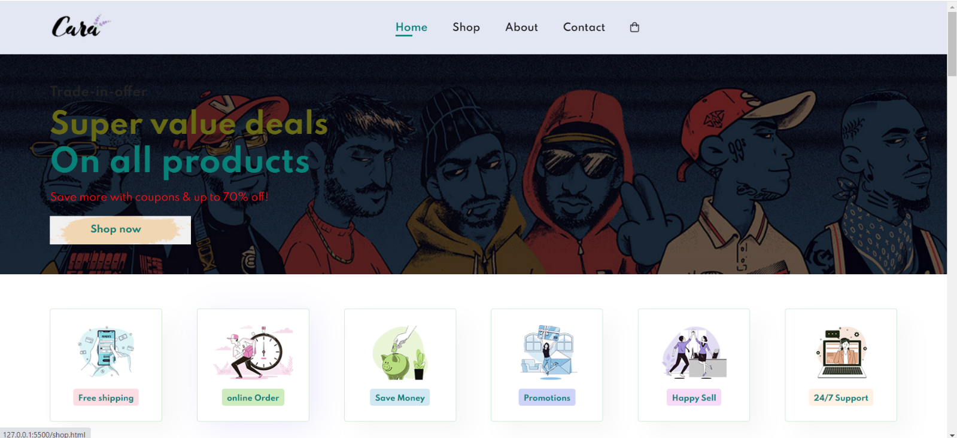

**7.1: Home page**

**PRODUCT LIST**

**7.2: Product list**

**SINGLE PRODUCT PAGE**

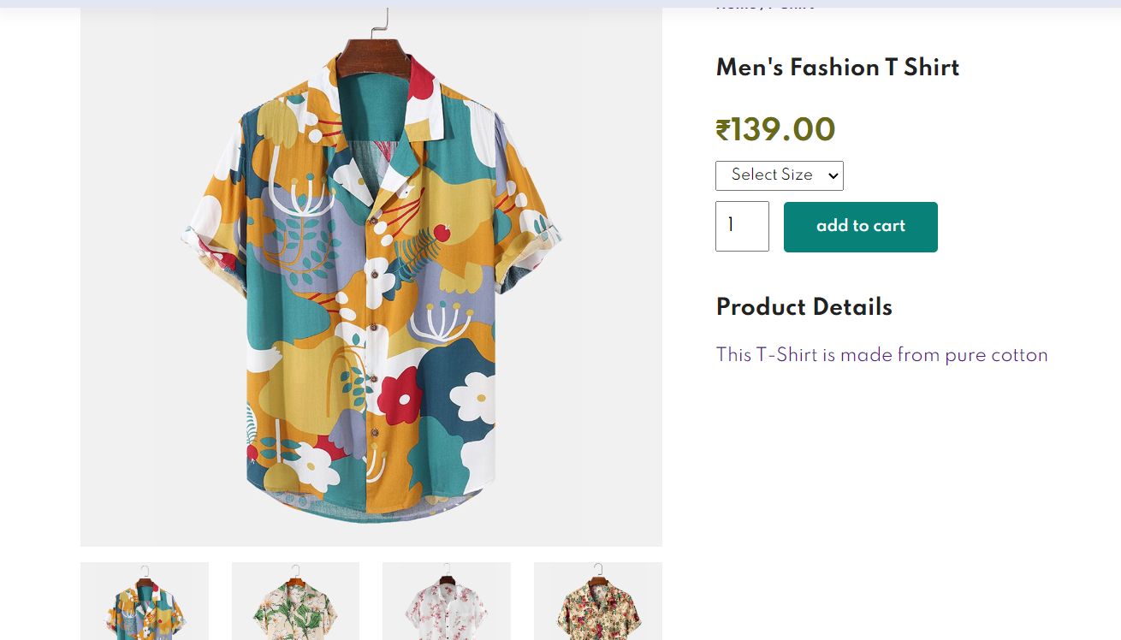

**7.3: Single Product page**

**NAVIAGATION BAR**

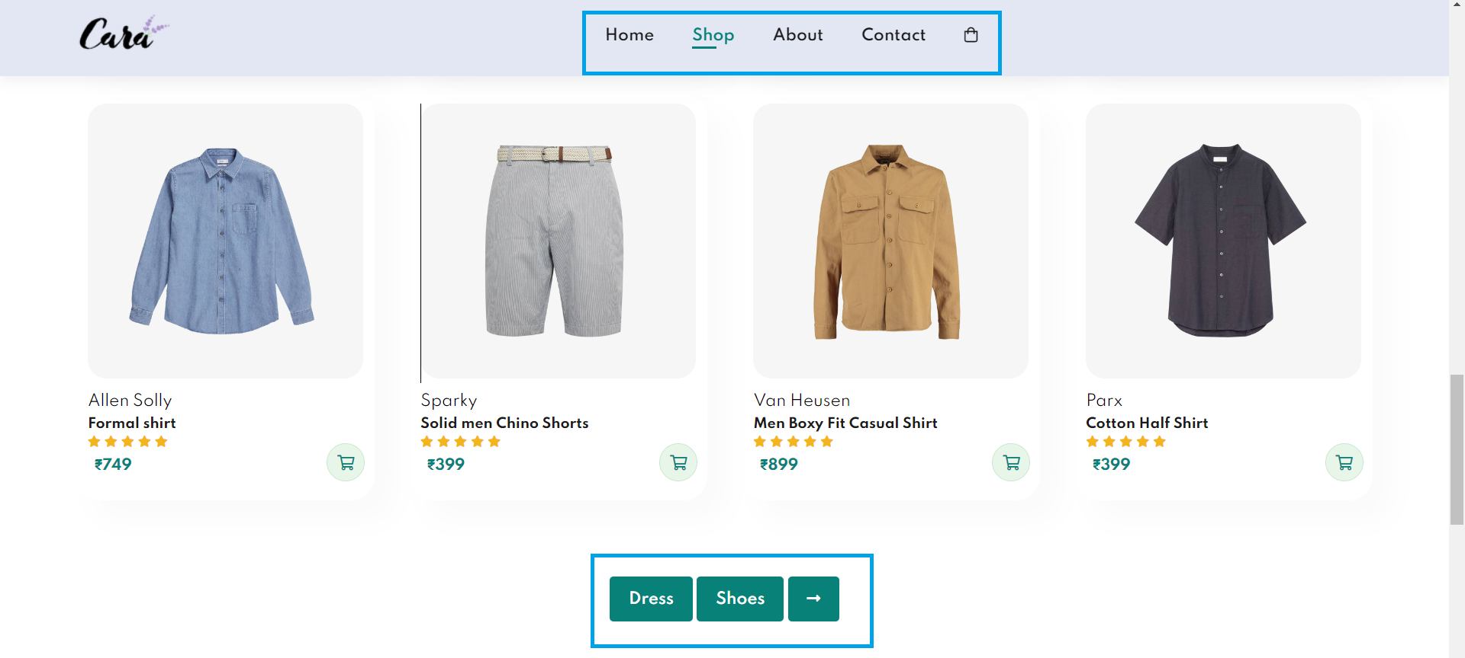

**7.4: Navigation Bar**

**CONTACT PAGE**

**7.5: Contact Page**

**CART PAGE**

**7.6: Cart page**

**CHAPTER - 08**

**SCOPE OF AN E-COMMERCE WEBSITE**

In the digital age, an e-commerce website serves as the virtual storefront for businesses, enabling them to showcase their products or services, conduct transactions, and interact with customers. The scope of an e-commerce website is a comprehensive blueprint outlining the functionalities, features, and objectives it aims to achieve in catering to both business goals and user needs.

1. Purpose and Objectives

At the core of defining an e-commerce website's scope lies its purpose and objectives. This encompasses understanding the business's goals—whether it's to increase sales, expand market reach, or enhance customer engagement. Defining clear objectives sets the foundation for planning the website's functionalities and user experience.

2. Product Catalog and Management

The scope includes defining the range and types of products or services the website will offer. It involves designing an intuitive catalog structure, ensuring easy navigation for users to explore and locate desired items. Additionally, product management encompasses inventory tracking, categorization, and showcasing product details effectively.

3. User Experience and Interface Design

Creating an engaging and user-friendly interface is pivotal. The scope involves crafting an intuitive user experience (UX) that guides visitors seamlessly through the website. This includes considerations for responsive design, clear navigation menus, appealing visuals, and persuasive call-to-action elements aimed at encouraging conversions.

4. Secure Transactions and Payment Gateway Integration

Ensuring secure online transactions is imperative. The scope involves implementing robust security measures to safeguard customer data and integrating trusted payment gateways. This includes SSL encryption, PCI compliance, and various payment options to accommodate customer preferences.

5. Order Processing and Management

Efficient order processing and management are crucial components. The scope entails streamlining the purchase process, from cart management to checkout, order tracking, and confirmation. Additionally, it involves inventory management to avoid stockouts and handle returns or exchanges effectively.

6. Marketing and Promotions

An e-commerce website's scope extends to marketing strategies and promotional activities. This encompasses features for discounts, coupons, and loyalty programs, as well as integration with social media and email marketing tools to reach and engage customers effectively.

**CHAPTER - 09**

**CONCLUSION**

The culmination of our e-commerce website project signifies not just the completion of a digital platform but a testament to meticulous planning, dedicated efforts, and a vision to revolutionize the online shopping experience. As we wrap up this phase, it's essential to reflect on our achievements, acknowledge the challenges conquered, and chart a course for the future.

1. Achievements and Milestones

Our journey commenced with a vision to create a dynamic, user-centric e-commerce platform. Through collective expertise and unwavering commitment, we have successfully brought this vision to life. From the initial stages of conceptualization to the final implementation, each milestone marked a step forward in achieving our goals.

The website stands as a testament to our dedication, boasting a seamless user interface, intuitive navigation, and an extensive product catalog meticulously crafted to cater to diverse customer preferences. The integration of cutting-edge technologies has elevated the user experience, offering a blend of aesthetic appeal and functional efficiency.

2. Challenges Overcome and Lessons Learned

However, this journey was not without its share of challenges. Adversities ranging from technical complexities to logistical hurdles tested our resilience. Yet, these challenges were not deterrents; they were opportunities to innovate and evolve.

Through collaborative problem-solving and an agile approach, we conquered these obstacles. Each challenge served as a learning curve, imparting invaluable lessons in adaptability, teamwork, and the importance of contingency planning in navigating the dynamic landscape of e-commerce.

3. Impact and Results

The impact of our e-commerce website on the business has been nothing short of remarkable. The platform's launch heralded a surge in online sales, exceeding initial projections. Customer engagement metrics reflected positive feedback, indicating a seamless and satisfactory shopping experience.

The website's robust infrastructure facilitated streamlined order processing, ensuring prompt deliveries and customer satisfaction. Furthermore, the integration of data analytics enabled us to derive actionable insights, guiding strategic decisions and paving the way for targeted marketing initiatives.

4. Future Endeavors and Recommendations

Looking ahead, our journey doesn't culminate here—it evolves. As we envision the future, there are avenues for continuous enhancement and expansion. The ever-evolving landscape of e-commerce presents opportunities for refinement and innovation.

To further fortify our position, future endeavors should focus on continuous optimization. This involves harnessing emerging technologies, enhancing mobile compatibility, refining customer support mechanisms, and leveraging data-driven insights to personalize the shopping experience.

Moreover, the scalability of our platform is imperative. We should strategize for scalability, ensuring that the website architecture accommodates future expansions and technological advancements seamlessly.

In conclusion, our e-commerce website project has been a testament to collaboration, innovation, and resilience. As we bid adieu to this phase, let us carry forward the spirit of innovation and adaptability. Our journey has merely begun, and the future beckons with endless possibilities. Let us embrace the challenges, leverage the opportunities, and continue crafting unparalleled digital experiences for our customers.

This comprehensive conclusion encapsulates the journey of an e-commerce website project, acknowledging achievements, challenges, impact, and future recommendations. If you need more specific information or details, feel free to ask!

**CHAPTER - 10**

**REFERENCES**

E-COMMERCE WEBSITE USING HTML, CSS & JAVA SCRIPT

1. HTML and CSS: Design and Build Websites, By Jon Duckett.

2. Eloquent JavaScript, By Marijn Hoverbike.

3. Web Design with HTML, CSS, JavaScript and jQuery Set,

By Jon Duckett.

4. E-Commerce Essentials, By Kenneth C. Laudon and Carol

Guercio Traver.

5. https://www.codewithrandom.com/2023/03/15/ecommerce-website-

using-html-css-and-javascript-simple-and-responsive-ecommerce-

website/